Part 1

|  |  |
| --- | --- |
| T1 | T2 |
|  | t2WantsToEnter = true; |
|  | while (favoredThread == 1) |
|  | { |
|  | while (t1WantsToEnter) ; |
| T1WantsToEnter = true; |  |
| While(favoredThread == 2) |  |
| { |  |
| While(t2WantsToEnter); |  |
| favoredThread = 1; |  |
| } |  |
| //critical section code |  |
| T1 IN CRITICAL SECTION |  |
|  | favoredThread = 2; |
|  | } |
|  | // critical section code |
|  | T2 IN CRITICAL SECTION |
|  |  |

Part 2

|  |  |
| --- | --- |
| T1 | T2 |
|  | t2WantsToEnter = true; |
|  | while (favoredThread == 1) |
|  | { |
|  | while (t1WantsToEnter) ; |
|  | favoredThread = 2; |
|  | } |
|  | // critical section code |
| T1WantsToEnter = true; |  |
| While(favoredThread == 2) |  |
| { |  |
| While(t2WantsToEnter) ; |  |
|  | t2WantsToEnter = false; |
|  | // non-critical code |
|  | T2WantsToEnter = true; |
| At any of these points, t1 checks if t2WantsToEnter again, but it will always come up as true | While(favoredThread == 1) |
| // critical section code |
|  |

Part 3

Mutual Exclusion Failed

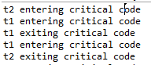

Mutual Exclusion Successful

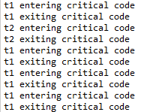

Thank you